Logo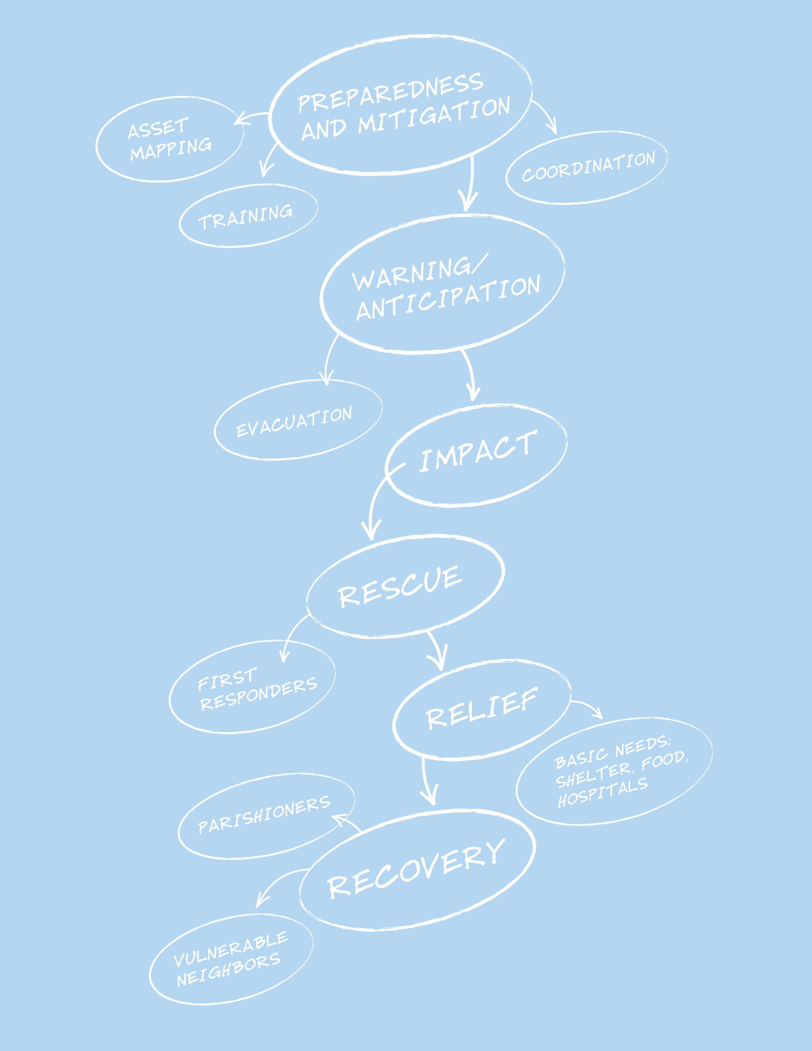

|  |  |
| --- | --- |
|  | Preparedness Planning GuideFor Congregations and Parishes (Bronze Level Version) |
|
|

From the Director

Dear Episcopal Church Leaders,

Though we don’t always want to think about it, one of our roles as a church in the community is to be prepared to be of assistance after a disaster. We plan for four basic reasons:

* To mitigate the damage to our church community’s buildings and belongings;
* To be able to resume the business of the church as soon as possible post-disaster;
* To support our parishioners in times of crisis;
* To assist to our vulnerable neighbors after an emergency.

The role of Episcopal Relief & Development’s US Disaster Program is to inspire, connect and equip leaders of the US Episcopal Church to prepare for hazards that might affect their communities, as well as mitigate the impact of those disasters and help the vulnerable make a full and sustained recovery.

*The Preparedness Planning Guide for Congregations and Parishes* is designed to help a congregation plan for a disaster, from taking inventory of physical and human assets to determining its niche in assisting vulnerable people in the larger community. The **“Comprehensive Version”** of the guide takes about 10 to 15 hours to complete. But we recognize some congregations might not yet be ready for the full process. This **“Bronze Level”** version gathers the most basic information needed in times of disaster.

Additionally, a **“Silver Level”** version, which includes necessary basic information to protect parishioners and church property in times of disaster, and also lays the foundation for congregations interested in responding to their most vulnerable neighbors, is also available. All three versions of the planning guide canbe downloaded from the Resource Library of our website, [www.episcopalrelief.org/resourcelibrary](http://www.episcopalrelief.org/resourcelibrary). An index that cross-references the sections of all three guides can be found at the end of this resource.

Episcopal Relief & Development’s US Disaster Program is working with dioceses around the country to help them be better prepared for emergencies. That includes training and supporting Diocesan Disaster Coordinators, who have been appointed by their bishops. A list of Diocesan Disaster Coordinators can be found on our website at [www.episcopalrelief.org/usdisaster](http://www.episcopalrelief.org/usdisaster). They should be your first support and resource through this planning process.

*The Preparedness Planning Guide for Congregations and Parishes* comes from the collected wisdom of the Church. To compile this guide, we gathered examples of parish and diocesan disaster preparedness guides from around the country as well as from other denominations. We utilized the most important elements from each, while trying to stay as simple as possible. Please let us know if there’s anything in this guide that you think should be changed, added or eliminated, and feel free to edit according to your local context.

Thanks for all you do in this important work,

Katie Mears

Director, US Disaster Program

Episcopal Relief & Development

Thank-you

This guide is not the creation of Episcopal Relief & Development’s U.S. Disaster Program; it is a compilation of the great work of:

Province IV Disaster Preparedness and Response Commission

The Episcopal Diocese of Arkansas

The Episcopal Diocese of Central Florida

The Episcopal Diocese of Central Pennsylvania

The Episcopal Diocese of Connecticut

The Episcopal Diocese of East Tennessee

The Episcopal Diocese of Florida

The Episcopal Diocese of Kansas

The Episcopal Diocese of Louisiana

The Episcopal Diocese of Rio Grande

The Episcopal Diocese of South Carolina

The Episcopal Diocese of Southeast Florida

The Episcopal Diocese of Southwestern Virginia

The Episcopal Diocese of Texas

The Episcopal Diocese of West Tennessee

The Episcopal Diocese of West Texas

Lutheran Episcopal Services in Mississippi

This work owes special thanks to:

Karin Hamilton and her committee in the Diocese of Connecticut

and Carolyn Gibbs in the Diocese of Texas

Dave Baylor

Dianne Britton

The Rev. Daniel Harris

Sharon Jones

The Rev. Curtis Metzger

The Rev. Canon E. Mark Stevenson

Carol Stewart

Ryan Velasco

The Rev. Paul Wehner

and

Participants of the Disaster 101 Training in the Diocese of Olympia

© Copyright 2011



|  |  |  |  |  |  |  |  |  |  |  |  |  |  |  |  |  |  |  |  |  |  |  |  |  |  |  |  |  |  |  |  |  |  |
| --- | --- | --- | --- | --- | --- | --- | --- | --- | --- | --- | --- | --- | --- | --- | --- | --- | --- | --- | --- | --- | --- | --- | --- | --- | --- | --- | --- | --- | --- | --- | --- | --- | --- |
| Our Congregation’s Disaster Plan  |  |  | | --- | --- | |  | | | * Congregation/Church: |  | | * Phone: |  | | * Address: |  | |  | | | * Congregational Disaster Coordinator |  | | * Cell-phone: |  | | * Landline/Phone: |  | |  | | | * Diocesan Disaster Coordinator: |  | | * Cell-phone: |  | | * Landline/Phone: |  | |  | | | * Date of Completion: |  | |  | | | * Scheduled Review: |  | |  |

## Disaster Leadership Team:

## Contact Information

Instructions: Fill out the following form with contact information for your Congregational Disaster Coordinator and the Disaster Leadership Team. Even if your team consists of two people, capture their contact information.

|  |  |  |
| --- | --- | --- |
| **Congregational Disaster Coordinator:** | * **Landline:** |  |
| * **Cell Phone:** |  |
| * **Email:** |  |
| * **Name:** | **Role/Designated Tasks:** |  |
| **Address:** |  |
| **Landline:** |  |
| **Cell Phone:** |  |
| **Email:** |  |
| * **Name:** | **Role/Designated Tasks:** |  |
| **Address:** |  |
| **Landline:** |  |
| **Cell Phone:** |  |
| **Email:** |  |
| * **Name:** | **Role/Designated Tasks:** |  |
| **Address:** |  |
| **Landline:** |  |
| **Cell Phone:** |  |
| **Email:** |  |
| * **Name:** | **Role/Designated Tasks:** |  |
| **Address:** |  |
| **Landline:** |  |
| **Cell Phone:** |  |
| **Email:** |  |
| * **Name:** | **Role/Designated Tasks:** |  |
| **Address:** |  |
| **Landline:** |  |
| **Cell Phone:** |  |
| **Email:** |  |
| * **Name:** | **Role/Designated Tasks:** |  |
| **Address:** |  |
| **Landline:** |  |
| **Cell Phone:** |  |
| **Email:** |  |

## Identifying Groups that Include or Serve Vulnerable People

People with special needs will be at higher risk during a disaster. Take the time to identify those people within your congregation, and brainstorm what problems they may face and how you could help with those problems as a congregation.

Instructions:List the groups in the parish that are either comprised of or serve people who might be especially vulnerable after a disaster. These might include senior citizens’ groups, groups for new mothers, and religious education programs that include children with special needs. List the contacts for each group, so that they can be contacted after a disaster to help assess needs and facilitate the response.

|  |  |  |
| --- | --- | --- |
| **Group** | **Contact** | **Types of needs members might have.** |
| *The Senior Citizens Club is comprised of parishioners aged 65 and older.* | Betty Jones | *Difficulty evacuating. Medical conditions.* |
| *The Lay Eucharistic Visitors have a current list of people who are home-bound or who are in the hospital.* | Deacon Williams | *Difficulty evacuating. Medical conditions.* |
|  |  |  |
|  |  |  |
|  |  |  |
|  |  |  |
|  |  |  |
|  |  |  |
|  |  |  |
|  |  |  |

## Insurance Information

Make a list of all your insurance information and contacts. Be sure to have a copy of this information in a **secure place off-site** and have another copy that someone can take with them if your community is evacuated.

|  |  |
| --- | --- |
| * **Policy Number:** |  |
| * **Policy is with:** |  |
| Phone: |  |
| Address: |  |
| * **Agent:** |  |
| Phone: |  |
| Address: |  |
| * **Original Policy is kept:** |  |
| Address: |  |
| * **Copy of policy is kept offsite:** |  |
| Address: |  |
| * **Policy Type:** | *(Example – Replacement value type)* |
| Total Value: |  |
| * **Policy covers:** | *Earthquake, hurricane, robbery, fire, breakage, etc.* |
| * **Other policies:** |  |
| * **Policy review:** |  |
| When: |  |
| By who: |  |

## 

Be sure to note where off-site copies are kept and who can access them.

|  |  |
| --- | --- |
| **Off-site Copies** | |
| * **Where:** | *(Ex: Diocese has a copy)* |
| * **Who:** | *Susan Wu* |
| Phone: | *xxx-xxx-xxxx* |
| Cell: |  |

## Diocesan Contact Information

Instructions: Change, remove and add titles as relevant to your diocese.

|  |  |  |
| --- | --- | --- |
| * **Bishop**   Name: | Address: |  |
| Office Phone: |  |
| Cell Phone: |  |
| Home Phone: |  |
| Email: |  |
| * **Canon for Stewardship/Administration**   Name: | Address: |  |
| Office Phone: |  |
| Cell Phone: |  |
| Home Phone: |  |
| Email: |  |
| * **Assistant to the Bishop**   Name: | Address: |  |
| Office Phone: |  |
| Cell Phone: |  |
| Home Phone: |  |
| Email: |  |
| * **Assistant to the Canon**   Name: | Address: |  |
| Office Phone: |  |
| Cell Phone: |  |
| Home Phone: |  |
| Email: |  |
| * **Diocesan Disaster Coordinator**   Name: | Address: |  |
| Office Phone: |  |
| Cell Phone: |  |
| Home Phone: |  |
| Email: |  |
| * **Communications Director**   Name: | Address: |  |
| Office Phone: |  |
| Cell Phone: |  |
| Home Phone: |  |
| Email: |  |
| * **Other**   Name: | Address: |  |
| Office Phone: |  |
| Cell Phone: |  |
| Home Phone: |  |
| Email: |  |

## 

**Appendix: Table of Contents, All Versions**

|  |  |  |  |
| --- | --- | --- | --- |
| **Table of Contents for Comprehensive, Silver and Bronze Planning Guides** | Comp. | Silver | Bronze |
| **Leadership**  Who will take responsibility for preparedness activities? | **11** |  |  |
| •   Congregational Disaster Coordinator / Disaster Leadership Team | 12 | 7 | 7 |
| •   Disaster Leadership Team – Contact Information | 13 |  |  |
| **Goals**  What does your congregation want to do in case of disaster? | **15** |  |  |
| •   Preparedness Goals / Forming Goals | 16 | 8 |  |
| •   Congregational Goals | 17 | 8 |  |
| **Risk Assessment**  What emergencies have happened before and what should you prepare for? | **19** |  |  |
| •   Local Crisis History | 20 |  |  |
| •   Brainstorm Possible Disasters and Emergencies | 21 | 9 |  |
| •   Identify Groups that Include or Serve Vulnerable People | 22 | 10 | 8 |
| **Property Assets**  What do you have that you need to protect? | **23** |  |  |
| •   Inventories of Property-Related Assets | 24 | 11 |  |
| •   Inventory Form | 25 |  |  |
| •   Items to Protect | 26 |  |  |
| •   Items to Bring in an Evacuation | 27 |  |  |
| •   Church "Go Kit" | 28 |  |  |
| •   Insurance Information | 29 | 12 | 9 |
| •   Secure Storage of Archives and Records | 30 | 13 |  |
| **Response & Recovery Capacity**  What and whom do you have that will help you respond after an emergency? | **31** |  |  |
| •   Congregational Resources | 32 | 14 |  |
| •   Congregational Activities Resources | 33 | 15 |  |
| •   Members with Disaster-Related Skills/Certification/Resources | 35 |  |  |
| •   Member Questionnaire | 36 |  |  |
| •   Goals and Response | 39 | 17 |  |
| **Communication & Outreach**  Whom do you need to contact after an emergency, how and for what purpose? | **41** |  |  |
| •   Important Contacts | 42 |  |  |
| •   Diocesan Contact Information | 43 | 18 | 10 |
| •   Church Staff Contact Information | 44 | 19 |  |
| •   People with Financial Authorization Approval | 44 | 19 |  |
| •   Congregation’s Emergency Contacts | 45 | 20 |  |
| •   Local Preparedness and Response Organizations | 46 |  |  |
| •   Vendor Contact List | 47 |  |  |
| •   Outside Users of the Building | 48 | 21 |  |
| •   Local Media Information | 49 |  |  |
| **Developing Templates for Initial Response**  The first steps you should take in the immediate aftermath of a disaster | **51** | **22** |  |
| •   Example: Major Disasters with Warning | 52 | 23 |  |
| •   Example: Local Emergencies with No Warning | 53 | 24 |  |
| •   Template: Major Disasters with Warning | 54 | 25 |  |
| •   Template: Major Disasters with No Warning | 55 | 26 |  |
| •   Template: Local Emergencies with Warning | 56 | 27 |  |
| •   Template: Local Emergencies with No Warning | 57 | 28 |  |